**Student Database System Report**

**Embedded Systems Online Diploma**

**Eng. Mahmoud Essam Mahfouz**

[**Progress Page**](https://www.learn-in-depth.com/online-diploma/mahmoud1mahfouz%40gmail.com)

**6/12/2022**

# **Problem Statement**

A simple software for student information management system which can perform the following operations:

1. Store first name of the student.
2. Store last name of the student.
3. Store unique roll number for every student.
4. Store GPA for every student.
5. Store courses registered by the student.

# **Approach**

The idea is to form an individual functions for every operation. All the functions are unified to form software.

1. Add student details manually.
2. Add student details from file.
3. Find the student by the given roll number.
4. Find the student by the given first name.
5. Find the student registered in a course.
6. Count number of students.
7. Delete a student by the given roll number.
8. Update a student by the given roll number.
9. Print all student’s data.
10. Exit the program.

# **Main.c**

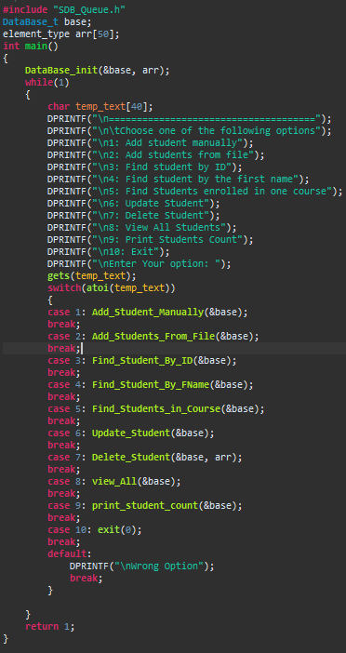

# **SDB_Queue.h**

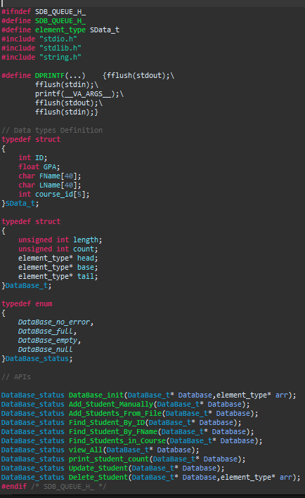

# **SDB_Queue.c**

This file includes the functions used in the main program:

## **DataBase_init**

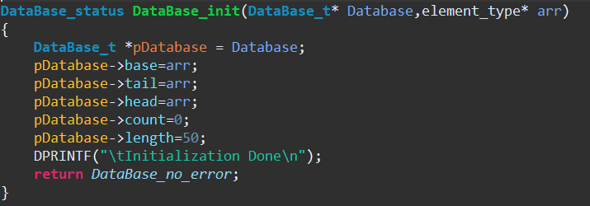

## **Add_Studnets_Manually**

## 

## **Add_Students_From_File**

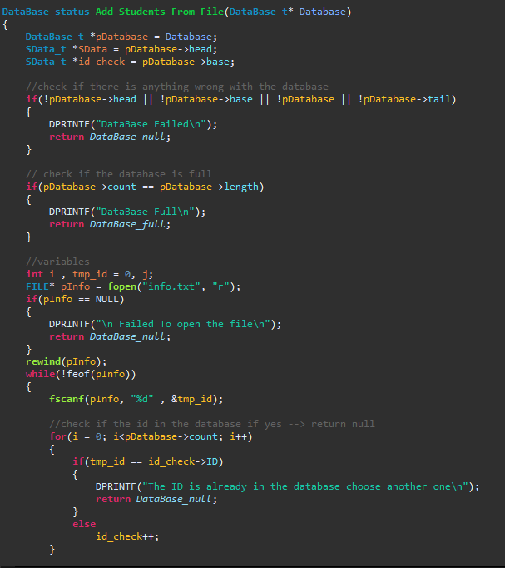

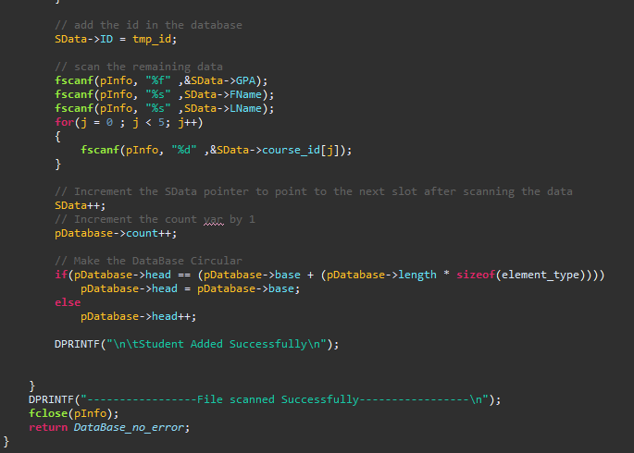



## **Find_Student_By_ID**

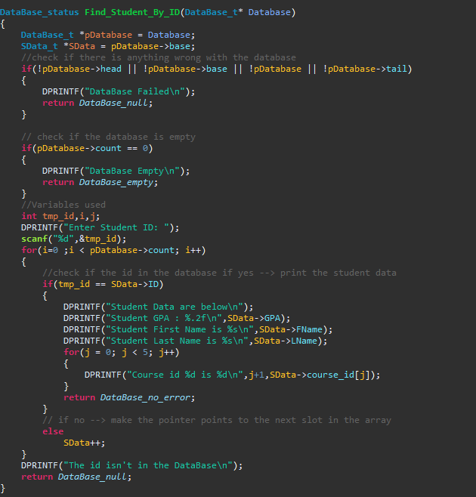

## **Find_Student_By_FName**

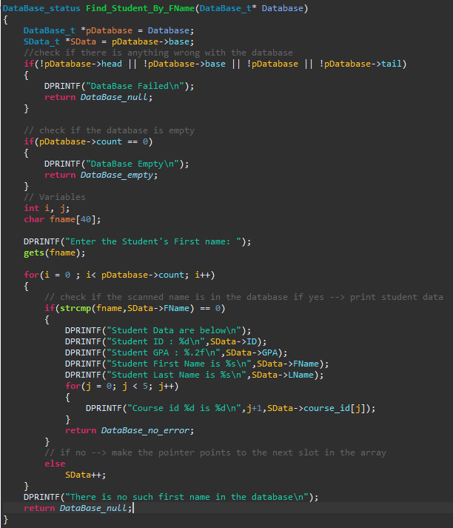

## **Find_Students_In_Course**

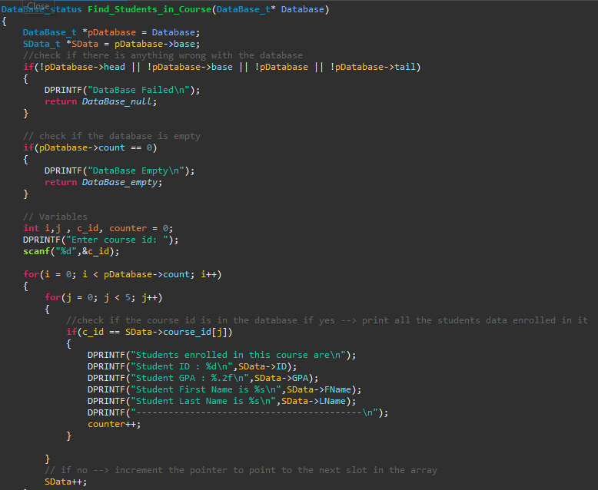

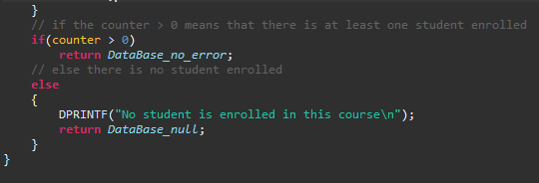

## **Print_Students_Count**

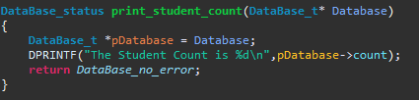

## **Delete_Student**

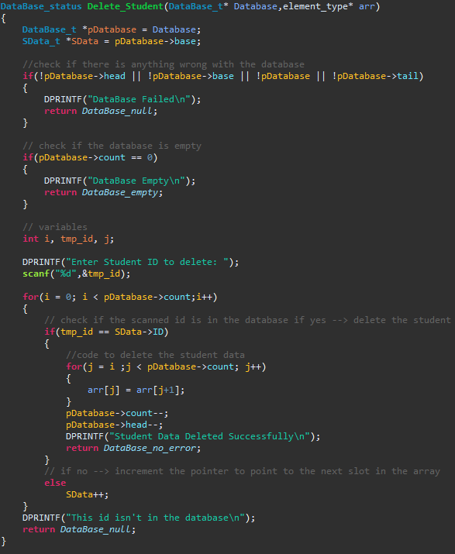

## **Update_Stuedent**

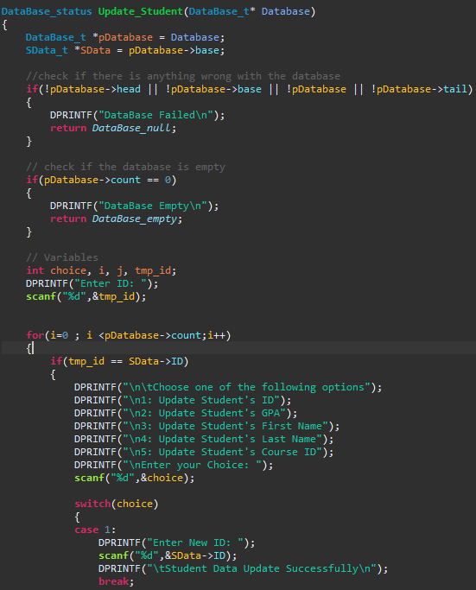

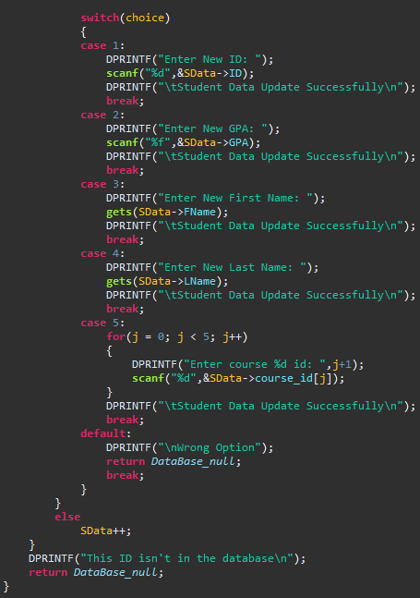

## **View_All**

